Regular Zigzag Shapes
# Source: AI Source: Provided by: [Data Path: Persons Table -> ID Column: 1, Name_En Column: Motasem Essam] -> From: [ChatGPT] on [7/25/2026]
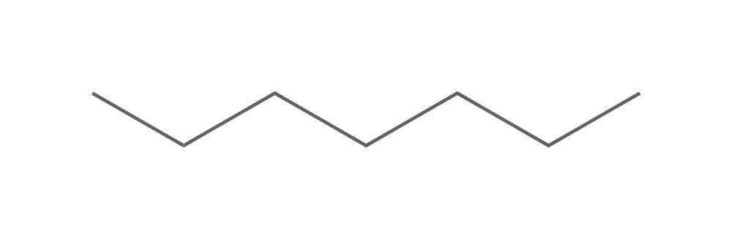
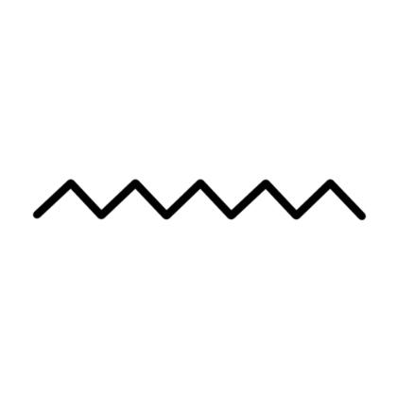
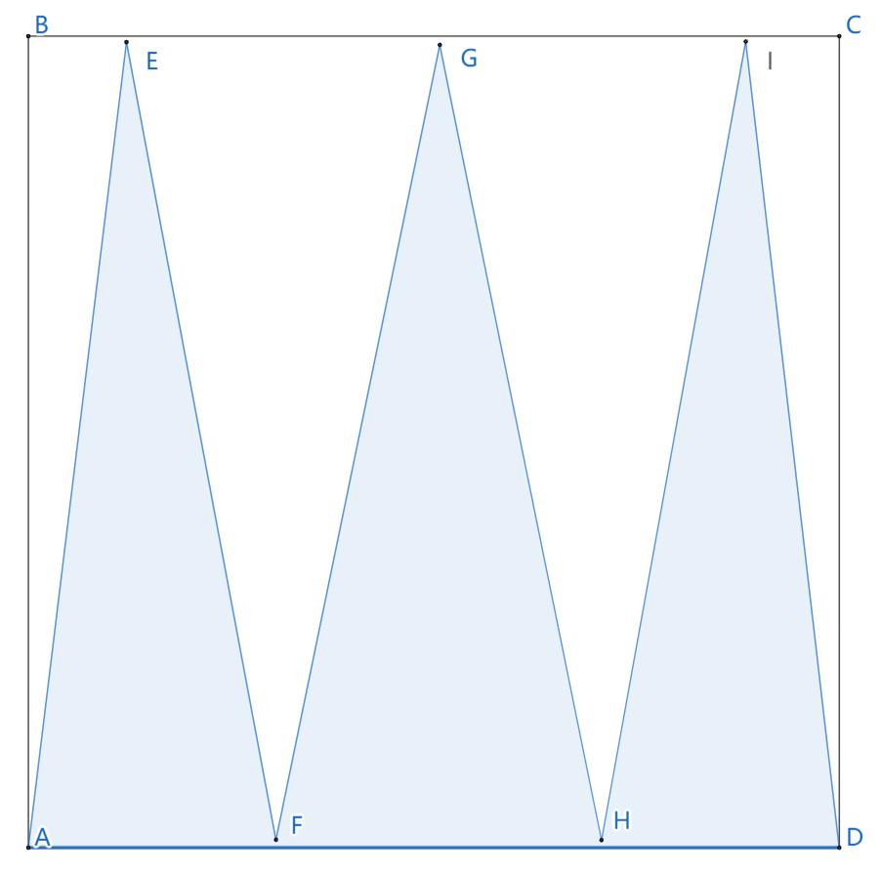
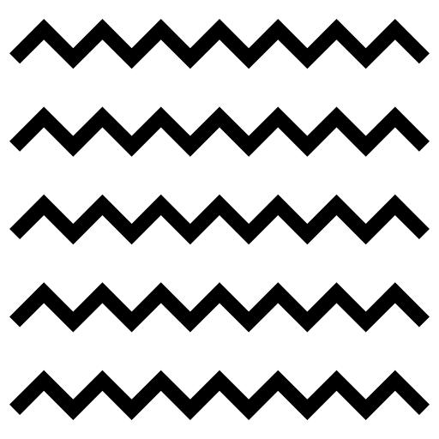

Definition
# Source: AI Source: Provided by: [Data Path: Persons Table -> ID Column: 1, Name_En Column: Motasem Essam] -> From: [ChatGPT] on [7/25/2026]
A Regular Zigzag Shape is a zigzag shape that follows a consistent and repeating geometric pattern.
Its consecutive line segments and direction changes follow a systematic arrangement. Depending on the definition being used, this may involve equal segment lengths, equal or repeating angles, or a regularly repeating sequence of directions.
Important: “Regular zigzag shape” is a descriptive geometric term rather than a universally standardized polygon category. Regularity should therefore be defined by the specific properties of the zigzag being studied.

Fundamental Concept
# Source: AI Source: Provided by: [Data Path: Persons Table -> ID Column: 1, Name_En Column: Motasem Essam] -> From: [ChatGPT] on [7/25/2026]
A regular zigzag is created by connecting straight-line segments in a repeated pattern.
For example:
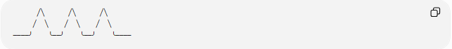
╱╲ ╱╲ ╱╲
╱ ╲ ╱ ╲ ╱ ╲
────╯ ╰──╯ ╰──╯ ╰────
The same basic pattern is repeated along the path.
For a sequence of points:
$$P_{1}→P_{2}→P_{3}→⋯→P_{n}$$
the geometric relationships between successive segments follow a consistent rule.

Main Characteristics
# Source: AI Source: Provided by: [Data Path: Persons Table -> ID Column: 1, Name_En Column: Motasem Essam] -> From: [ChatGPT] on [7/25/2026]
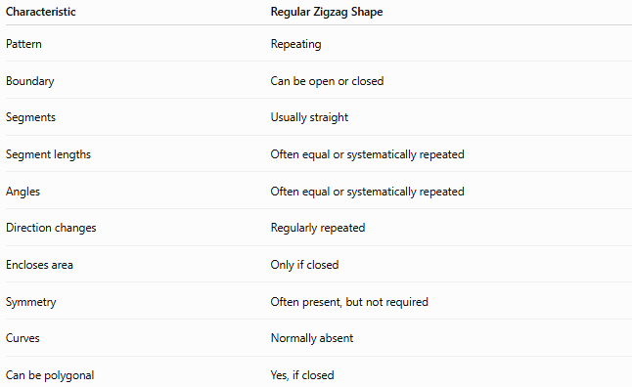
Characteristic | Regular Zigzag Shape
Pattern | Repeating
Boundary | Can be open or closed
Segments | Usually straight
Segment lengths | Often equal or systematically repeated
Angles | Often equal or systematically repeated
Direction changes | Regularly repeated
Encloses area | Only if closed
Symmetry | Often present, but not required
Curves | Normally absent
Can be polygonal | Yes, if closed

Basic Structure
# Source: AI Source: Provided by: [Data Path: Persons Table -> ID Column: 1, Name_En Column: Motasem Essam] -> From: [ChatGPT] on [7/25/2026]
A regular zigzag can be represented by repeating segments:
╱╲╱╲╱╲╱╲╱
If each segment has the same length $l$, then:
$$l_{1}=l_{2}=l_{3}=⋯=l_{n}=l$$
If the turns also repeat with the same angle, the zigzag has a regular angular pattern.

Types of Regular Zigzag Shapes
# Source: AI Source: Provided by: [Data Path: Persons Table -> ID Column: 1, Name_En Column: Motasem Essam] -> From: [ChatGPT] on [7/25/2026]
Regular zigzag shapes can be classified according to whether their boundary is open or closed:
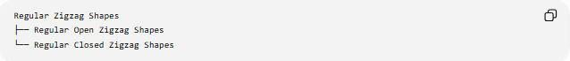
Regular Zigzag Shapes
├── Regular Open Zigzag Shapes
└── Regular Closed Zigzag Shapes

1-Regular Open Zigzag Shapes
# Source: AI Source: Provided by: [Data Path: Persons Table -> ID Column: 1, Name_En Column: Motasem Essam] -> From: [ChatGPT] on [7/25/2026]
A Regular Open Zigzag Shape has a repeating zigzag pattern but does not return to its starting point.
╱╲╱╲╱╲╱╲
It has two endpoints and does not enclose an area.
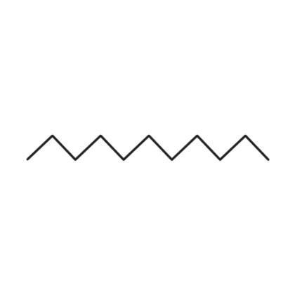
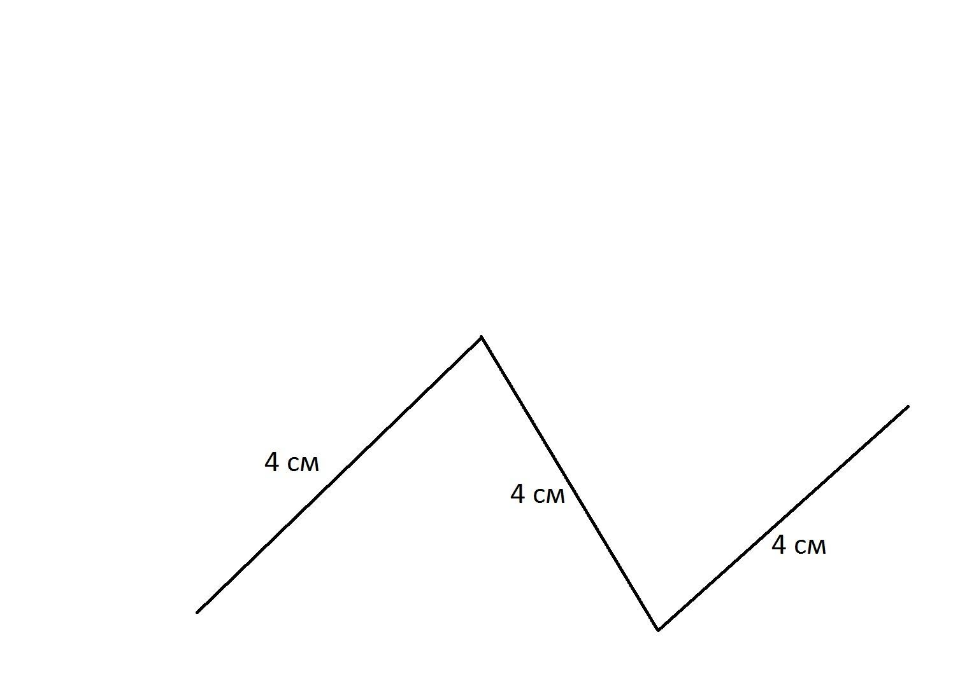
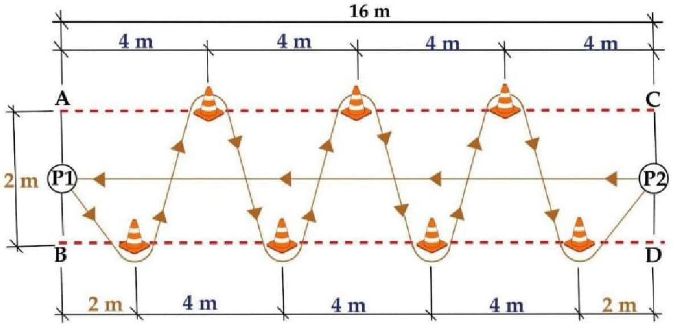

2-Regular Closed Zigzag Shapes
# Source: AI Source: Provided by: [Data Path: Persons Table -> ID Column: 1, Name_En Column: Motasem Essam] -> From: [ChatGPT] on [7/25/2026]
A Regular Closed Zigzag Shape follows a repeating zigzag pattern and eventually returns to its starting point.
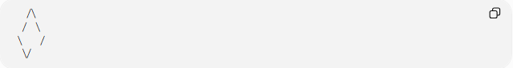
╱╲
╱ ╲
╲ ╱
╲╱
It forms a closed boundary and therefore encloses a region.

Segment Lengths
# Source: AI Source: Provided by: [Data Path: Persons Table -> ID Column: 1, Name_En Column: Motasem Essam] -> From: [ChatGPT] on [7/25/2026]
A regular zigzag often uses equal segment lengths.
For $n$segments of length $l$:
$$\boxed{L=nl}$$
where:
- $L$= total path length
- $n$= number of segments
- $l$= length of each segment
For example, if there are 8 segments and each has length $5$cm:
$$L=8\left(5\right)=40\text{ cm}$$

Repeating Angles
# Source: AI Source: Provided by: [Data Path: Persons Table -> ID Column: 1, Name_En Column: Motasem Essam] -> From: [ChatGPT] on [7/25/2026]
Regular zigzags can also have a repeated turning angle.
For example:
╱╲╱╲╱╲╱╲
If every corresponding turn has the same magnitude, then:
$$θ_{1}=θ_{2}=θ_{3}=⋯$$
The repeated angles create the characteristic regular zigzag pattern.

Symmetry
# Source: AI Source: Provided by: [Data Path: Persons Table -> ID Column: 1, Name_En Column: Motasem Essam] -> From: [ChatGPT] on [7/25/2026]
Many regular zigzag shapes have symmetry.
For example, a zigzag can have reflection symmetry:
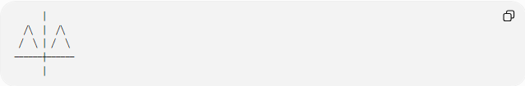
│
╱╲ │ ╱╲
╱ ╲ │ ╱ ╲
──────┼──────
│
However:
$$\boxed{\text{Regular}≠\text{necessarily symmetric}}$$
Regularity describes the consistency of the geometric pattern, while symmetry describes invariance under a transformation.

Open vs. Closed Regular Zigzags
# Source: AI Source: Provided by: [Data Path: Persons Table -> ID Column: 1, Name_En Column: Motasem Essam] -> From: [ChatGPT] on [7/25/2026]
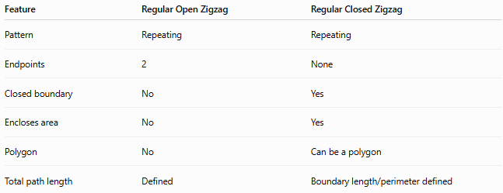
Feature | Regular Open Zigzag | Regular Closed Zigzag
Pattern | Repeating | Repeating
Endpoints | 2 | None
Closed boundary | No | Yes
Encloses area | No | Yes
Polygon | No | Can be a polygon
Total path length | Defined | Boundary length/perimeter defined

Regular vs. Irregular Zigzag Shapes
# Source: AI Source: Provided by: [Data Path: Persons Table -> ID Column: 1, Name_En Column: Motasem Essam] -> From: [ChatGPT] on [7/25/2026]
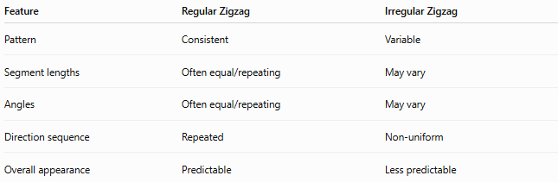
Feature | Regular Zigzag | Irregular Zigzag
Pattern | Consistent | Variable
Segment lengths | Often equal/repeating | May vary
Angles | Often equal/repeating | May vary
Direction sequence | Repeated | Non-uniform
Overall appearance | Predictable | Less predictable

Examples

Example 1 – Equal-Segment Zigzag
# Source: AI Source: Provided by: [Data Path: Persons Table -> ID Column: 1, Name_En Column: Motasem Essam] -> From: [ChatGPT] on [7/25/2026]
╱╲╱╲╱╲╱╲
Each segment follows the same repeating pattern.

Example 2 – Regular Open Zigzag
# Source: AI Source: Provided by: [Data Path: Persons Table -> ID Column: 1, Name_En Column: Motasem Essam] -> From: [ChatGPT] on [7/25/2026]
╱╲╱╲╱╲╱
The pattern repeats but the path remains open.

Example 3 – Regular Closed Zigzag
# Source: AI Source: Provided by: [Data Path: Persons Table -> ID Column: 1, Name_En Column: Motasem Essam] -> From: [ChatGPT] on [7/25/2026]
A repeating zigzag arrangement can be connected back to its starting point to form a closed geometric boundary.

Classification Summary
# Source: AI Source: Provided by: [Data Path: Persons Table -> ID Column: 1, Name_En Column: Motasem Essam] -> From: [ChatGPT] on [7/25/2026]
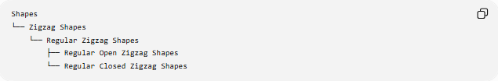
Shapes
└── Zigzag Shapes
└── Regular Zigzag Shapes
├── Regular Open Zigzag Shapes
└── Regular Closed Zigzag Shapes
Regular zigzags can also be described independently by symmetry:
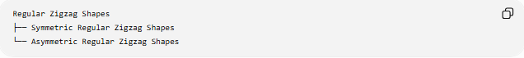
Regular Zigzag Shapes
├── Symmetric Regular Zigzag Shapes
└── Asymmetric Regular Zigzag Shapes
These classifications can overlap. For example, a zigzag can be regular + open + symmetric at the same time.

Key Points
# Source: AI Source: Provided by: [Data Path: Persons Table -> ID Column: 1, Name_En Column: Motasem Essam] -> From: [ChatGPT] on [7/25/2026]
- A Regular Zigzag Shape follows a consistent, repeating geometric pattern.
- Its segments are usually straight.
- Segment lengths may be equal or follow a repeating sequence.
- Turning angles may also be equal or follow a repeating sequence.
- It can be open or closed.
- A closed regular zigzag can form a polygon.
- Regularity and symmetry are different properties.
- “Regular zigzag” is mainly a descriptive classification, not a standard formal polygon class.

Conclusion
# Source: AI Source: Provided by: [Data Path: Persons Table -> ID Column: 1, Name_En Column: Motasem Essam] -> From: [ChatGPT] on [7/25/2026]
A Regular Zigzag Shape is characterized by a repeated and systematic arrangement of straight segments and directional changes. Its regularity comes from the consistency of its geometric pattern, while its open or closed nature determines whether it forms an unbounded path or an enclosed region.

